The SIX BELLS
COMMUNITY HUB
Peterstone Wentlooge
Community Benefit Society (PWCBS)

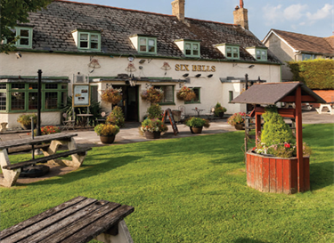
Community Share Offer Issue
January 2025
SAVE THE SIX BELLS COMMUNITY SHARE OFFER
ever thought of being part owner of a pub?
This is an opportunity for you to be a shareholder in the renovation of the 17th Century Six Bells Public House and Community Hub in Peterstone, Wentlooge, Newport, South Wales.
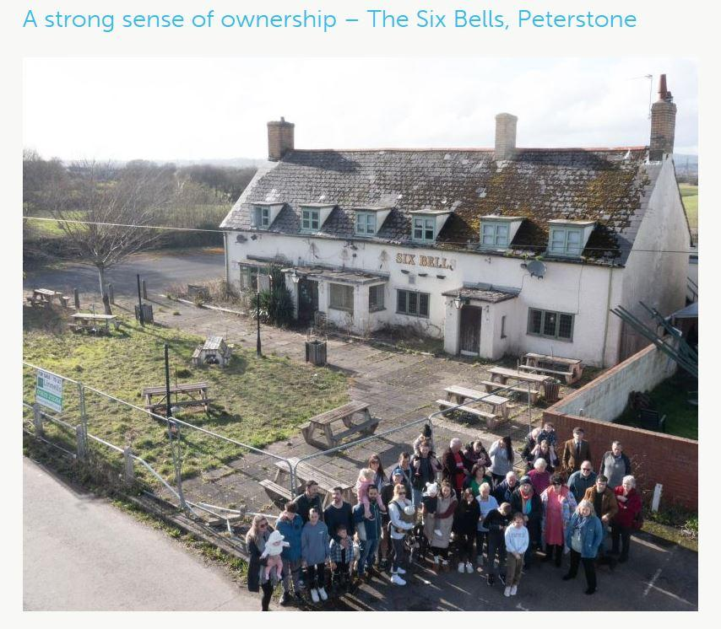

Together, we can preserve this piece of history and provide a destination for all generations to meet, socialise, enjoy activities and learn about the unique Gwent Levels.
SUMMARY OF OFFER
This document outlines a Community Share Offer for the Community Purchase of The Six Bells Public House, Broadstreet Common, Peterstone Wentlooge, Cardiff CF3 2TN
The historic Six Bells Pub is intended to be purchased by Peterstone Wentlooge Community Benefit Society Ltd, a Community Benefit Society (CBS) registered with the Financial Conduct Authority under the Cooperative and Community Benefit Societies Act 2014, registration number (8950).
FCA Listing and Society Rules available here: https://mutuals.fca.org.uk/Search/Society/31289
Society Website: https://www.savethesixbells.org/
- Variation to Original Offer Timetable. The original Offer Document stated a closing day of May 2025. As the Society continues its campaign to raise £450,000 to secure the Six Bells, the Steering Group has resolved to keep the share offer open beyond that date. This reflects the ongoing opportunity for community investment and our commitment to achieving full community ownership.
Main Terms

- Opening date: 19th January 2025
- Closing date: This is an open share offer – with no fixed closing date.
- Minimum individual investment: £100
- Maximum individual investment: £45,000 (£90,000 for organisations)
- Minimum total needed to proceed: £150,000
- Optimum target total: £250,000
- Maximum total: £450,000

THE OPPORTUNITY
We, the Peterstone Wentlooge Community Benefit Society (CBS) Ltd are delighted to announce that we are launching a Community Share offer for the Six Bells in Peterstone Wentlooge.
By becoming a member of Peterstone Wentlooge CBS Ltd via this community share offer, you will enable the purchase and restoration of the Six Bells to achieve its reopening as a vibrant community hub.
This is your opportunity to be part of an initiative to return this dearly loved, 17th century coach house to its former glory, as the centre of the Peterstone Village, but also a destination hub for the surrounding communities across South Wales.
At its core, the Six Bells will once again operate as a village pub - a warm, inclusive space where people can meet, celebrate and connect. Alongside this, a daytime café offer will ensure the hub is accessible to all generations throughout the day, providing a relaxed and welcoming environment for socialising, remote working and informal gatherings. As the only stopping-off point on the Wales Coast Path between Cardiff and Newport, the Six Bells will also provide much-needed refreshment and rest for walkers and visitors.
The hub will include a farm shop, showcasing produce from our fantastic local growers and suppliers, alongside essential groceries and locally made arts and crafts - supporting the local economy and reducing food miles.
The regional heritage and environment are deeply important to those who live on the Gwent Levels. A key feature of the hub will therefore be a Visitor and Discovery Centre focused on education, environmental awareness and wellbeing. Working closely with partners, we will celebrate the unique ecosystem of the Gwent Levels and its SSSI status, promote understanding of the Wales Coast Path, and provide opportunities for learning, nature connection, and community wellbeing activities including workshops, talks and mental health and social prescribing initiatives.
With the support of you, our shareholders, from the local and wider communities, we have a unique opportunity to create a thriving, sustainable community pub and hub: a place to socialise, celebrate our environment and history, strengthen wellbeing, and restore cohesion within our community.

TABLE OF CONTENTS
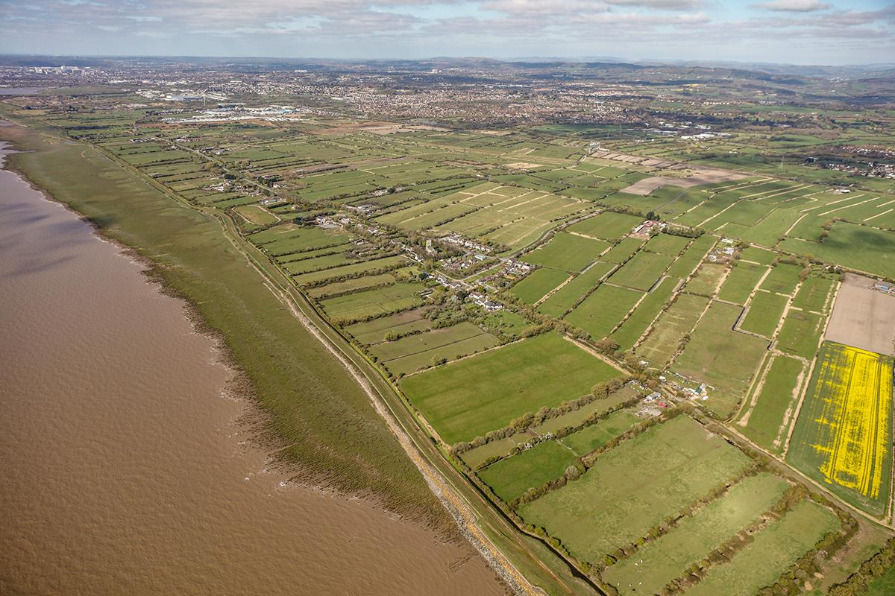
* https://www.livinglevels.org.uk/gallery

- Share Issue Summary
2 - Vision and Benefits for the Community
3 - The Community Benefit Society / How you can get Involved
4 - The Share offer
5 - Business Model Overview
6- Frequently Asked Questions
- SHARE ISSUE SUMMARY
Please read this document in conjunction with the Business Plan which can be downloaded from our website www.savethesixbells.org
The overall costs of the project are given in Section 2. The overall sources of funding are given in Section 3.
You are invited to invest in a community enterprise, established to buy the historic Six Bells pub, renovate it and open it as a multi-functional community hub including a welcoming food-led pub with a daytime cafe, farm shop and visitors’ centre celebrating the unique ecology, history and culture of the Gwent Levels.
In October 2018 the Six Bells pub ceased trading due to the landlord’s retirement and, since that time, the subsequent owners have tried without success to obtain planning permission to change use and redevelop it for residential dwellings. During that time the building has become an eyesore and attracted anti-social behaviour. A historic building has been degrading and the western Levels area has lost its heart.
A committed group of volunteers has been working to acquire the pub and grounds so that we can restore it, bring it into community ownership and reopen it. We have consulted the community; run many outreach and fundraising events; built an amazing group of volunteers; negotiated with the owner; commissioned valuation and project viability surveys; obtained legal advice; and established a CBS (Community Benefit Society) which as a legal entity registered with the FCA (Financial Conduct Authority), is able to buy the pub.
A community share offer is unregulated, as it is exempt from the Financial Services and Markets Act 2000 or subsidiary regulations, which means there is no right of complaint to the Financial Ombudsman, nor can you apply to the Financial Services Compensation Scheme.

The key points of the share offer:
- Minimum target: £150,000
- Optimum target: £250,000
- Maximum target: £450,000
- Minimum individual share investment: £100
- Maximum individual share investment: £45,000 (person) or £90,000 (institution)
Each share costs £10, therefore you must buy at least 10 shares to meet the £100 minimum and invest in multiples of £10.
- Variation to Original Offer Timetable. The original Offer Document stated a closing day of May 2025. As the Society continues its campaign to raise £450,000 to secure the Six Bells, the Steering Group has resolved to keep the share offer open beyond that date. This reflects the ongoing opportunity for community investment and our commitment to achieving full community ownership.
IMPORTANT: CAPITAL AT RISK WARNING
You could lose some, or all, of the money you invest in this community share offer, which is without recourse to the Financial Services Compensation Scheme or the Financial Ombudsman Service

Peterstone Wentlooge Community Benefit Society (PWCBS) is aiming to raise an initial £450,000 which is the purchase price agreed with the owner, and will ensure the purchase of the pub. We need an additional £10,250 for Land Transaction Tax, which we have already raised via events and donations. To maximise our chance of raising the money needed, we have applied for grants, will continue to fundraise via events and donations, and are now running this community share offer. If we are in the fortunate position to raise more than £450,000, then any extra will go towards refurbishment and initial running costs. Otherwise, we will do additional fundraising later to cover these costs.
The Peterstone Wentlooge Community Benefit Society Ltd Steering Group may choose to extend the period of the share offer for a short period if we believe that by doing so, we increase the chances of reaching the minimum or optimum target. The offer will close early if the maximum target is met.
- VISION AND BENEFITS FOR THE COMMUNITY
The closure of The Six Bells pub in 2018 was a loss of a vital social meeting place, not only for the village of Peterstone but also the surrounding areas and visitors from the nearby towns and cities.
Closure of village pubs has become a modern concern which has been exacerbated by the Covid years. The west side of the Gwent Levels has also seen the closure of the Lighthouse pub, which means there are now no facilities along this stretch of the Wales National Coastal Path for walkers and day visitors. The corridor along the sea wall has also declined due to minimal road maintenance, speeding and substantial fly tipping and waterway pollution, which is particularly problematic given that the area is a Site of Special Scientific Interest (SSSI) with rare and endangered species habitat.
To provide positive action to halt this decline, the Peterstone Wentlooge Community Benefit Society (CBS) Limited has been formed by committed individuals and businesses primarily from the village and attracted volunteers from the wider Newport and Cardiff Council areas. This CBS has been formed to raise funds to purchase the site, restore the building and provide a reinvigorated asset.
We aim to create community and environmental regeneration of the western Gwent Levels by:
- Provision of adaytime café offer - serving quality home-cooked food centred around local, seasonal produce and designed to be inclusive and accessible to all generations
- A farm shop supplying food and household essentials with a “plastic free” set up as far as possible. The shop will champion sustainable locally grown and produced goods, along with locally made crafts supporting our fantastic local producerspromoting sustainability, strengthening the local economy and attracting visitors to the area.
- A Visitor and Discovery Centre focused on education, heritage and wellbeing, celebrating the unique history, wildlife and SSSI status of the Wentlooge Levels and promoting understanding of the Wales Coast Path. Working with partners, this space will host educational activities, workshops and wellbeing initiatives that connect people with nature and support mental health. The outside grounds will be family friendly, with a play area, and will enhance biodiversity within the SSSI setting with plans for a community garden, a wildlife pond, bird observation and feeding stations. Planting will prioritise sustainable local species to encourage habitats that support wildlife, environmental education and community wellbeing.

Future phases may include visitor accommodation, further strengthening long-term business sustainability, supporting Coast Path tourism and reinforcing the Six Bells as a destination hub. At the heart of our project is the desire to improve outcomes for the community and the environment using the principles of The Well Being of Future Generations (Wales) Act 2015, and local council strategies. Refer to our business plan for more details of how this project fulfils those aims.
3. THE COMMUNITY BENEFIT SOCIETY AND HOW YOU CAN GET INVOLVED
3.1 What is a community benefit society (CBS)
A Community Benefit Society (CBS) exists to serve the broader community rather than individual members, unlike co-operative societies. CBSs are regulated by the Financial Conduct Authority under the Co-operative and Community Benefit Societies Act 2014, which mandates they operate for community benefit.
CBSs are democratically controlled on a one-member, one-vote basis. Profits must be reinvested into the community, though modest interest may be paid to shareholders if affordable. Assets owned by the CBS must also benefit the community.
You are invited to become a member and shareholder of the Peterstone Wentlooge Community Benefit Society Ltd (PWCBS), which will own and oversee the Six Bells Community Hub. The Steering Group will secure the hub, appoint a tenant to manage it, and coordinate its refurbishment with local volunteers.
PWCBS Ltd was created to enable the people of Peterstone and surrounding areas to secure and safeguard the future of the Six Bells. It operates as a not-for-profit CBS, following model rules from Cooperatives UK and is registered with the FCA. Copies of the Constitution and Business Plan are available on our website.
3.2 Shareholder engagement
When you invest you will automatically become a member of the Society.
This will also give you voting writes. At the first annual general meeting of members all the current Steering Group will stand down (although they can stand for re-election) and the members will elect a new Steering Group from amongst the members.
The purpose of the Society is to benefit the community
The purpose and objective of Peterstone Wentlooge CBS, as set out in our Society Rules are to “Carry on any business for the benefit of the community by providing a community hub in Peterstone Wentlooge, including the acquisition of property and/or land and any necessary renovations/alterations required to make it fit for purpose as a profitable business and successful social hub that directly improves wellbeing and quality of life for residents in the village, those in the surrounding areas and visitors.”
By buying shares and becoming a member you confirm that you support this objective, which your shares will help achieve.
The Steering Group will not run the hub on a day to day basis.
If we are successful the hub will contract with a tenant to run the pub/café. Prospective tenants will undergo a thorough selection process, requiring them to articulate their plans for aligning with our vision. This ensures that the pub's leadership is committed to delivering the identified benefits and maintaining the pub as a community asset. We will employ a manager to run the shop, facilitate the visitor center and work with our volunteers to assist.
Formal quarterly meetings will be held with the tenant to discuss performance, community input and future plans. Elected members of the Steering Group hold office for a period commencing immediately after the Members’ Meeting at which their election is declared, and ending at the conclusion of the third Annual Members’ Meeting after that.

4.THE SHARE OFFER
4.1 What are community shares?
Community Shares enable investors to become part owners of community organisations and assets of community value, through buying shares in a CBS. The CBS then uses the money to purchase assets, meet its business goals further its overall purpose, which must benefit the community.
Unlike typical company shares where voting power and control depends on the number of shares a shareholder has, community shares operate under a “one member, one vote” system, meaning all who invest have the same voting rights, regardless of how many shares they can afford to buy.
Community Shares cannot be sold to others (they can only be withdrawn from the CBS), but they are transferable on death or bankruptcy. A recipient may be nominated by the shareholder on a nomination form, to be provided in the future.
Community shares cannot increase in value. If the Society ever sold the asset, and made a profit before it was wound up and ceased to exist, investors would receive no more than their original investment back, and the balance would go to an appropriate similar community enterprise (this is called an Asset Lock). If the business ever runs into difficulty, it is possible that not all of the original investment could be repaid.
The Society must first have the funds to support withdrawal and we will only accept requests for withdrawal after three years. Community Shares cannot be sold on or transferred (except on death or bankruptcy). PWCBS will always have to ensure that repaying members is prudent, taking into account its objectives as a Community Benefit Society.
We will require 3 months’ notice for a share withdrawal. Please email savethe6bells@gmail.com to make a withdrawal.

4.2 the six bells share offer
The full details of share ownership and the terms of withdrawal are set out in our Society Rules, which can be found on the FCA website here: https://mutuals.fca.org.uk/Documents/Download/910805
Individuals (aged 16 years and over) and organisations can apply for membership by buying shares at a cost of £10 per share with a minimum of 10 shares, meaning a total minimum investment of £100 (for the January 2025 share offer). It is important to note that the value of the shares will not increase, the only financial benefit for members is the interest paid.
In order to prevent any individual holding a major share of the society, the maximum any individual can invest is £45,000.
Businesses and other organisations that are supportive can invest up to £90,000.
If the share offer is oversubscribed the Steering Group may close it early.
Shares cannot be withdrawn until at least three years have elapsed from the date of the share issue. In order to ensure that the CBS finances remain stable, no more than 10% of shares can be withdrawn per year, unless sufficient additional shares have been bought by others. Withdrawals will be approved on a first come first served basis. To remain a member you must keep at least 10 shares (worth £100 in total) in Peterstone Wentlooge CBS Ltd.
The Steering Group reserves the right to suspend share withdrawal if withdrawals would endanger the business (even if less than 10% of shares have been withdrawn in any year).
As PWCBS confers limited liability, the most you could lose due to business failure would be your original investment.
As this offer is unregulated, you have no right to complain to the Financial Ombudsman or to compensation.

INTEREST: No interest will be payable on the first 2 years of investment. After this, it cannot be guaranteed but our business plan aims to have the business in a position to pay interest on all shareholdings at 3% at the end of year 3 for that year and following years. Interest is only payable on the shareholding and is not cumulative.
Example: subject to affordability and approval by member vote, a member/shareholder who invested £1000 (100 shares for £10 each) in January/February 2025 and did not withdraw any shares for at least 5 years would earn the following over 5 years:
End of year 1 (February 2027): £0
End of year 2 (February 2028): £0
End of year 3 (February 2029): £30
End of year 4 (February 2030): £30
End of year 5 (February 2031): £30
Total interest over 5 years: £90
It is important to note that interest is not guaranteed and is subject to the Society being able to afford it.
The interest % value can be amended at the next Annual General Meeting provided it is proposed, seconded and approved by vote of the members/shareholders (according to the rules of the Society). All members/shareholders are eligible to vote.
The shares are not transferable (except on death or bankruptcy) and cannot be sold. The only way to recover the value of the shares purchased is to withdraw them from the CBS.
5.BUSINESS MODEL OVERVIEW
5.1 Generally
We have established the Peterstone Wentlooge Community Benefit Society (PWCBS) to purchase and refurbish the Six Bells through a combination of share offer, grants, donations and loans. PWCBS would own and maintain the fabric of the property and will contract with a tenant to run the pub/cafe. We will employ a manager to run the shop and facilitate the visitor centre.
Income from the tenant rent, shop and visitor centre will pay interest to shareholders at 3% per annum after an initial 3 years, once the business has been established
Project Phasing
The Six Bells buildings and external areas need significant renovation to reach the minimum standard needed to open as a public space. This Business Plan also proposes some improvements that are planned in the near future, e.g. energy efficient heating. To fund all of these at the start of the project, relies on the funding available, especially when there is no income from the various businesses that are proposed. It is also the recommendation of MJD Hughes [Ref-10] that the renovation and operation is carried out in phases.
Therefore, the project is split down into phases, to match receipt of the funding streams and a gradual build up of the business offer as shown below.
Phased Developments of the Six Bells Community Hub
Please read the full Business Plan which can be downloaded from our website www.savethesixbells.org
5.2 Profit and loss
The profit and loss estimates for the first 3 years of operating are shown in the table below. This includes the capital costs of the purchase and initial renovations of the premises and site, as well as the running of the business.
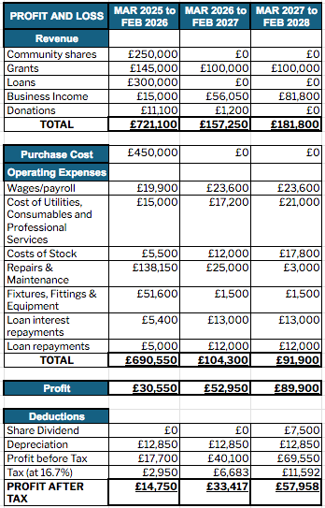
5.3 Sources of Funding
Grants, donations and loans
Using a combination of funding sources, we anticipate having sufficient funds to purchase the Six Bells by March 2025. The success of the share offer and planned applications will affect further fundraising efforts extending beyond March 2025.

Funding type | Name | Value | January | February | March
Shares | Community Share Offer | ~£250,000 | Share offer open
Grants | Community Facilities Partnership | £300,000 |  | Application and response
 | National Lottery | £100,000 | Application and response
Loans | WCVA | £300,000 | Application and response
Fundraising | GoFundMe page and events | £10,000 | Funding secured
6. FREQUENTLY ASKED QUESTIONS
  - Shareholders and People Involved
Why should I buy community shares?
PWCBS needs your investment to help purchase and renovate The Six Bells. Sufficient investment is required from the community to enable the Community Hub to be established as a sustainable business and destination.
Who will benefit from this project?
The local residents, those living in surrounding areas, visitors and the wider Gwent Levels community will all benefit directly from having this vital amenity.
The Six Bells Community Hub will provide a range of facilities to directly benefit all our supporters. The Hub will play a part in making a stronger, more vibrant and cohesive community in which to live and a more attractive place to visit. In addition, it is expected that the presence of a local Hub will support local businesses and enhance local community spirit.
Is this a good business proposition?
PWCBS have planned for the business to be a profitable venture, and require it to be profitable to ensure its continuity. We have carefully evaluated its strengths and weaknesses and our projections show that we can establish it as a successful business. It is well proven that communities that work together to set up such an enterprise will support it in the future. There are currently 182 Community owned pubs in the UK, with a 5 year survival rate of an outstanding 99%.
Will I receive interest from my shares?
We cannot guarantee any interest payments and at least the first two years would not earn any interest; but the business plan has a forecasted interest rate of 3% per year from year 3 onwards. The CBS steering group envisages that interest would be paid retrospectively after the end of year 3 and each subsequent year; but only if it is affordable to the business and approved by members/shareholders in a vote. Interest is not cumulative and only payable on the value of the shareholdings. Interest will be paid gross and it is each member’s responsibility to declare such earnings to HMRC if appropriate
Can I get tax relief on my shares?
We are waiting for confirmation from HMRC on whether shares will be eligible for tax relief, for now, you should not make an investment decision on the basis of tax relief.

Who are the people behind this project?
The PWCBS Steering Group consists of a group of local supporters who care passionately about the Six Bells, the social role of pubs, valuing the heritage of the area for future generations and maintaining a vibrant, welcoming community in the present. They have voluntarily donated their time and efforts over the last 4 years to develop the Business Plan and the way forward. They have engaged with all the appropriate bodies to ensure that the PWCBS is properly registered.
Our Actions and Plans have been informed by community surveys and requests for feedback meaning that the community’s desires are at the heart of our plans
We welcome everyone’s support and input and encourage you to get involved as much as you can. We also appreciate that some of you may want to be shareholders but are unable to get involved in the ‘day to day’.
See Section 7 for details of those in the current Steering Group.
Do these people have a personal benefit over other shareholders?
The current Steering Group and volunteers of the PWCBS represent a wide range of people, from Peterstone residents to people who live in Newport or Cardiff and, many of whom remember visiting the Six Bells in its heyday.
Their work has been supplemented with advice and considerable support from people and organisations such as the Architectural Heritage Foundation, Cwmpas and the Plunkett Foundation.
These people have given considerable time and effort and made significant donations already to this project. We have many members who are professionals or in businesses and they contribute their knowledge about building projects.
Please see section 7 and our business plan for more information on the people involved.
Do my shares give me voting rights?
Yes, they do. Everyone has an equal voice, regardless of the size of their investment. This is the ‘One member, One Vote’ principle giving you the opportunity to have a say in how the Six Bells Hub is run.
How do I get my money back?
You will be able to apply to withdraw your shares after the first three years. You will need to give at least three months’ notice. Only 10% of shares can be withdrawn in any given year and withdrawals will be prioritised on a first come first served basis.
You cannot sell or transfer your shares, and withdrawals must be funded from surpluses or new capital raised from members. The Steering Group may suspend withdrawals depending on the long-term interests of the Society, the need to maintain adequate reserves, and the commitment to the community we serve. To remain a member of the Society you must keep at least 10 shares (worth £100 in total) in PWCBS.

What happens if we don’t meet the minimum share offer target?
If the minimum target is not achieved, we will consult with investors to look at the next steps and possible ways forward. We do not expect to be able to go ahead with the purchase without the minimum community share offer. However, it is possible that the purchase may still go ahead if there were sufficient funds from other sources, e.g. grants. If this is not possible, all monies will be returned.
What is my maximum financial risk?
Your maximum financial risk will be the amount of money invested in share purchases. Although you will be a part owner of the Six Bells, because it will be through Peterstone Wentlooge CBS Ltd, which is an organisation with limited liability, you will not be personally liable for any money beyond that amount.
  - The Purchase of the Six Bells site
Will you be paying a fair price for the Six Bells site?
We have had two market appraisal valuations of the building in December 2022 and February 2024 by MJD Hughes. In line with this valuation a price has been agreed with the current owner for the purchase of the Six Bells. We have always maintained that there is an element of community value in us acquiring control of the Six Bells on behalf of our community. With this in mind, the committee has full confidence in the business plan and the impact the purchase costs have on it.
What happens if the purchase of the Six Bells Community Hub falls through?
It is possible that we will be unable to complete the purchase, even after we have met the minimum target and secured sufficient funds. In the unlikely event that this happens we would return any funds we have received through the share offer, after deducting any remaining losses. Losses would be kept to a minimum.
We have already agreed to pay a £10,000 non-refundable deposit to the owner to take the property off the market. We raised this deposit through donations and events and it would not be refunded if we are unable to complete the sale due to not raising enough funds.
Will you need to fundraise after the building has been purchased?
We expect to do more fundraising after purchasing the building to cover renovation and start-up costs. This will likely include grant applications, events and potentially another community share offer.
Will I get my investment back if the Six Bells Community Hub fails after the building has been bought?
In the event that the business was no longer viable and had to be wound up, all the assets, including the freehold of the building, would be sold and the sale proceeds (after paying any creditors) would be divided between the shareholders up to and in proportion to the value of their shares. Note that some of the grants we are applying for require a charge on the building for a set number of years. This means that if the assets need to be sold before those years are up, the grant awarding body would have priority over shareholders in being repaid. Therefore, whilst shareholders cannot receive more than the value initially invested, they may receive less.
IMPORTANT: This share offer is unregulated, as it is exempt from the Financial Services and Markets Act 2000 or subsidiary regulations, which means there is no right of complaint to the Financial Ombudsman, nor can you apply to the Financial Services Compensation Scheme.

  - running the six bells

How will the Six Bells Community Hub be run when it is operating?
At the first AGM following the share offer, all members of the current steering group (listed in Section 7) will stand down and a new Steering Group will be elected. This could include current steering group members, but can also include other members/shareholders. This new Steering Group will be the Board of Directors, who are legally responsible for the running of the Society including overseeing the development and running of the Six Bells(assuming the purchase goes ahead).

This Steering Group will oversee the performance of the business and seek to ensure that it meets the goals set down in the Business Plan.

The plan is to appoint an experienced tenant to run the day-to-day pub and cafe under a tenancy agreement with PWCBS. This is the strong view of the community, as it brings in essential experience and minimizes the draw on community time.

There will be effective governance and reporting arrangements in place to monitor financial and other performance. A formal ‘open book’ agreement will be sought to share feedback and other information between the Society and the tenant. Shareholders/members will be invited to annual meetings to discuss performance and vote on significant decisions about the future of the Six Bells Community Hub.The visitors centre and shop will be set up by the Steering Group, and initially staffed by volunteers. Subsequently a manager will be appointed who will be responsible for managing the volunteers, relationships with our partners, diary of events and stocking of the shop.

Who will make the day-to-day decisions about the business?
The appointed tenant will be in control of the day to day running of the running of the pubs and cafe which operates within the premises of the Six Bells owned by the PWCBS.

The manager of the shop and visitors centre will be responsible for day-to-day decisions for that part of the business - reporting into the Steering Group.

The tenant will be responsible for employing and managing their own staff to work within the pub and café

The Visitors Centre and Shop will start under the supervision of the Steering Group but a manager will eventually be employed.

What if a suitable tenant cannot be found by the planned opening time?
We will open the pub with a ‘stand in’ manager, who will be supported by the Steering Group. There is experience of the pub trade amongst the volunteers and we are confident that we will be able to find a suitable manager.

What if the necessary expertise is not available
An essential part of the planned approach developed with the community is to appoint an experienced and resourceful tenant with a track record of success. This may be achieved through engagement of a professional consultant who has experience of such recruitment. The tenant will appoint suitable staff and will be encouraged to recruit locally.

What if the tenant leaves suddenly?
An arrangement will be sought to source a ‘stand in’ manager in this event, and the Steering Group will step in to support the ‘stand in’ whilst a new tenant is sought.

  - Key risks (and responses to them)

What if the required level of funding is not achieved?
This prospectus lays out what funding is necessary, from where and the current position, albeit yet to be secured. If adequate funding is not achieved then all monies will be returned, less a small amount necessarily incurred by this share offer. It should also be noted that several other potential smaller sources of grants have been identified and will be followed up separately. It remains critically important that the community invests to achieve its strong desire to establish the Six Bells Community Hub on the Wentlooge Levels.

What if the setup costs are higher than anticipated?
Several estimates of the purchase price and setup costs have been carried out to give us the confidence to proceed.

For the property purchase price, we have commissioned two market valuations in December 2022 and February 2024 by chartered surveyor MJ Hughes, who is experienced in pub valuations and was recommended by the Plunkett Foundation, who have supported many communities to successfully purchase their local pub.

We plan to open the Six Bells in a phased way, starting with part of the building. This will enable us to manage renovation costs and means that the pub, community shop and visitors centre can begin trading before all renovations are completed.

For the refurbishment costs, the estimates in the current business plan and prospectus have been reviewed by both the Steering Group and by independent consultants. Our Renovation Works Stream is made up from supporters who are industry professionals in building and construction. They have used their knowledge and expertise to estimate costs of refurbishment using a combination of bought and volunteer labour.

  - Data Protection

What does PWCBS do with the data I provide?
Your personal data will be used purely for management of the share offer, shares and those communications relevant to your membership of PWCBS. Activities referred to above and for communications related to those indicated by you on your application form. Aside from the software companies we use for storage and communications, your personal data will not, under any circumstances, be passed to any third party. We manage your data in line with data protection legislation (General Data Protection Regulation 2018 (GDPR)) and only use software that comply with this too. For more information on General Data Protection Regulation 2018 (GDPR) click here
Anonymous summary statistics may be produced to monitor total number of applicants, total number and value of shares purchased, average value per applicant, breakdown of groups of values and number of applicants within each village / town.
If you have provided an email address you will receive email communications from savethe6bells@gmail.com and/or any other email that is set up for society communication purposes. If you have not provided an email address we will contact you, if needed, via telephone or post where required.

7. Interim Steering Group
An interim steering group has stepped forward to run PWCBS until the first AGM when members have joined and a formal election of the positions can take place. Members of the interim Steering group are listed below. This does cover all the people who have been involved in getting the project to this point, several other dedicated volunteers have contributed their time.

Amanda Reynolds - Chair
Amanda has expertise in building partnerships and stakeholder engagement as a Senior Partnerships Manager. Amanda is skilled in setting and maintaining project timelines, communication strategies, and implementing efficient working practices. Her strategic oversight ensures accountability, transparency, and that project milestones are met. Amanda brings a wealth of experience in strategy and development, management skills, presentation and marketing skills. Having lived Peterstone village for over 20 years Amanda is passionate about developing and maintaining a thriving community hub that all can benefit from.

Holly Tomlinson – Secretary
Holly works for an environmental think tank (IEEP UK) where she focuses on agricultural and environmental policy analysis for public and third sector organisations. This role also includes grant writing and reporting to grant funders. She also co-manages Blas Gwent, a recently established community focussed organic vegetable farm in Peterstone Wentlooge. She has significant experience of social enterprises having set up and worked in cooperatives and a Community Interest Company. She has a graduate diploma in law and over 5 years’ experience ensuring compliance within a highly regulated sector (energy).

Ruth Winstanley – Treasurer
Ruth has 30 Years’ experience in Housing Management and currently manages a team who house the Homeless. She is eager to use her skills to ensure compliance and Housing Law is met so that the project is sustainable. She has taken the lead in community projects within the Housing Associations she has worked. She loved engaging and consulting residents, in a large Sheltered complex , to help turn a very bland large area of mown grass into a place they could sit and chat and call it their own.

Sarah Jones - Renovations Lead
Sarah is a Chartered Civil Engineer with extensive experience of structural and civil design projects from domestic to large industrial, and from concept to construction detailing. She is a key member of the PWCBS sub-committee “SSB Renovations Group” which has other members who are a qualified electrician, qualified plumber and builder. Sarah is experienced in building condition surveys and infrastructure layouts and has access to other professionals such as fire engineers, architects and refurbishment engineers. Sarah lives in Cardiff, but has fond memories of visiting the Six Bells for meals and the kids’ play area and so strongly supports the project.

Helen Colvin - Fundraising
Helen is passionate about the potential of the Six Bells site and driven to progress this project. As a principal researcher in the Civil Service, she brings management skills, research and policy expertise and experience in developing Civil Service business cases. She has worked with the Cabinet Office in policy development and evaluation and has also worked in policy and practice, designing effective, evaluable services to deliver specific outcomes.

Leon Tarr - Hospitality & Business Lead
Leon brings over 25 years of experience in the hospitality sector, with a proven track record in managing hotels, bars, and nightclubs for both independent and corporate groups. His expertise extends to leasing tenanted properties where he honed his operational and business development skills. As a personal licence holder, Leon has actively contributed to industry initiatives, including leading the Cardiff branch of Pubwatch in collaboration with South Wales Police, promoting best practices and community safety within the sector. He now represents Radnor Hills, a leading Welsh water provider, driving strategic relationships with key stakeholders across the hospitality industry.

Ellen Law - Information Centre Coordination & Political Outreach
Ellen’s experience of developing community projects including hubs in local government is extensive, particularly building relationships with people to promote diversity. Her interest in development of rewilding projects is her main motivation for engaging with this ambitious programme of change for our village.

8. APPLICATION TO BUY SHARES
Shareholder Details
Forenames: | Surname:
Date of Birth (if under 16): | Intentionally left blank
Or
Company Name:

Nominated Company Representative:
Address
House Name / Number | Street
Town/City | County/State
Postcode | Country
Email | Phone
Mobile
Purchaser Details (only if different from above)
Forename: | Surname:
Address
House Name / Number | Street
Town/City | County/State
Postcode | Country
Email | Phone
Mobile
Number of shares wanted at £10 each:
Number(minimum 10) | Total Value (Number x £10)
Bank Account to receive any interest on the shares and/or refund in the event that less than £150,000 raised and share offer does not proceed
Account holder name(s)
Sort Code | Account No.
Details needed to match payment with purchaser
The reference on the bank transfer should be: purchaser surname, initial(s) (or company name) and postcode but if space does not allow this or payment has already been made under a different reference another is fine. Regardless, please write it below.
Name of account holder (if different to above) | Payment reference
Please tick the appropriate payment box:

I have enclosed a cheque with this form, made payable to Peterstone Wentlooge CBS Ltd., for the total value of the shares applied for; or

I have transferred the sum of money equal to the total value of the shares applied for to:
The Co-operative Bank PLC Account name: Peterstone Wentlooge (CBS) Ltd.
Sort Code: 08 92 99 Account No: 67314755
IMPORTANT: if paying by bank transfer the reference must be: Purchaser's surname & initial(s) (or company name) and postcode
Please post or deliver to: The Treasurer, Peterstone Wentlooge Community Benefit Society Limited c/o Ruth Winstanley, Harefield, Broad Street Common, Peterstone Wentlooge, CF3 2TN Receipts for the subscriptions will be issued by email whenever possible.
By buying these shares, I agree to all the information disclosed here being held on a computer database in compliance with EU General Data Protection Regulations (GDPR). I understand that this information will be used by Peterstone Wentlooge (CBS) Ltd only & will not be passed to third parties.
I confirm that:
• I have read and understood the terms of the Share Offer document.
• I understand that this application, when accepted, forms a contract subject to English Law.
• I am over 16 years of age. I also understand that shares bought for someone under 16 years old do not confer society membership or voting
rights until the shareholder becomes 16.
• I am not purchasing more than 4,500 shares, if an individual or 9,000 shares if a company.
• I am not relying on any information which is not included in the Share Offer document.
• I will give proof of my identity and address, if necessary, for anti-money laundering purposes.

Signed: .................................................................................................(Purchaser or Authorised Signatory) Date: ..................................

https://plunkett.co.uk/community-pubs-headline-grabbers/#:~:text=Expanding%20and%20thriving&text=Plunkett's%20data%20shows%20there%20are,helping%20on%20a%20regular%20basis.

